AREA OF COMPOUND SHAPES
Pearson Edexcel - Thursday 8 November 2018 - Paper 2 (Calculator) Foundation Tier

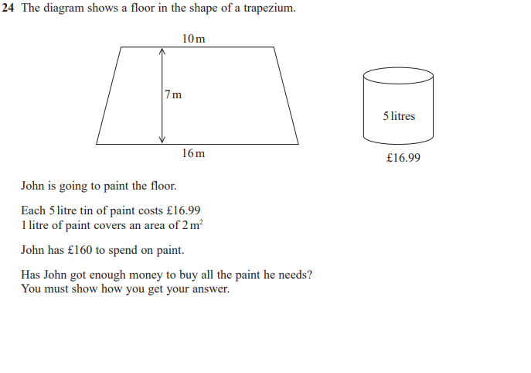

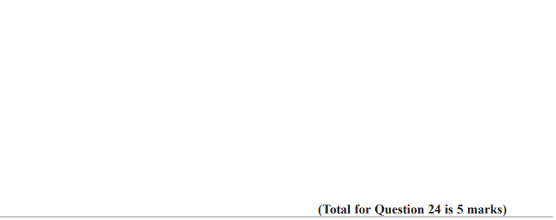

Pearson Edexcel - Wednesday 8 November 2017 - Paper 3 (Calculator) Foundation Tier

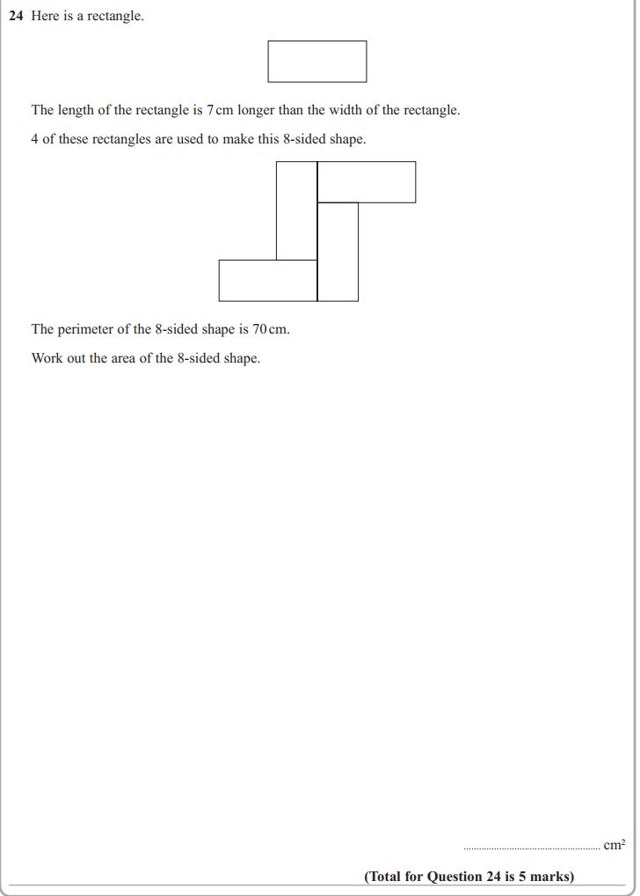

Pearson Edexcel – Specimen 1 - Paper 1 (Non-Calculator) Foundation Tier

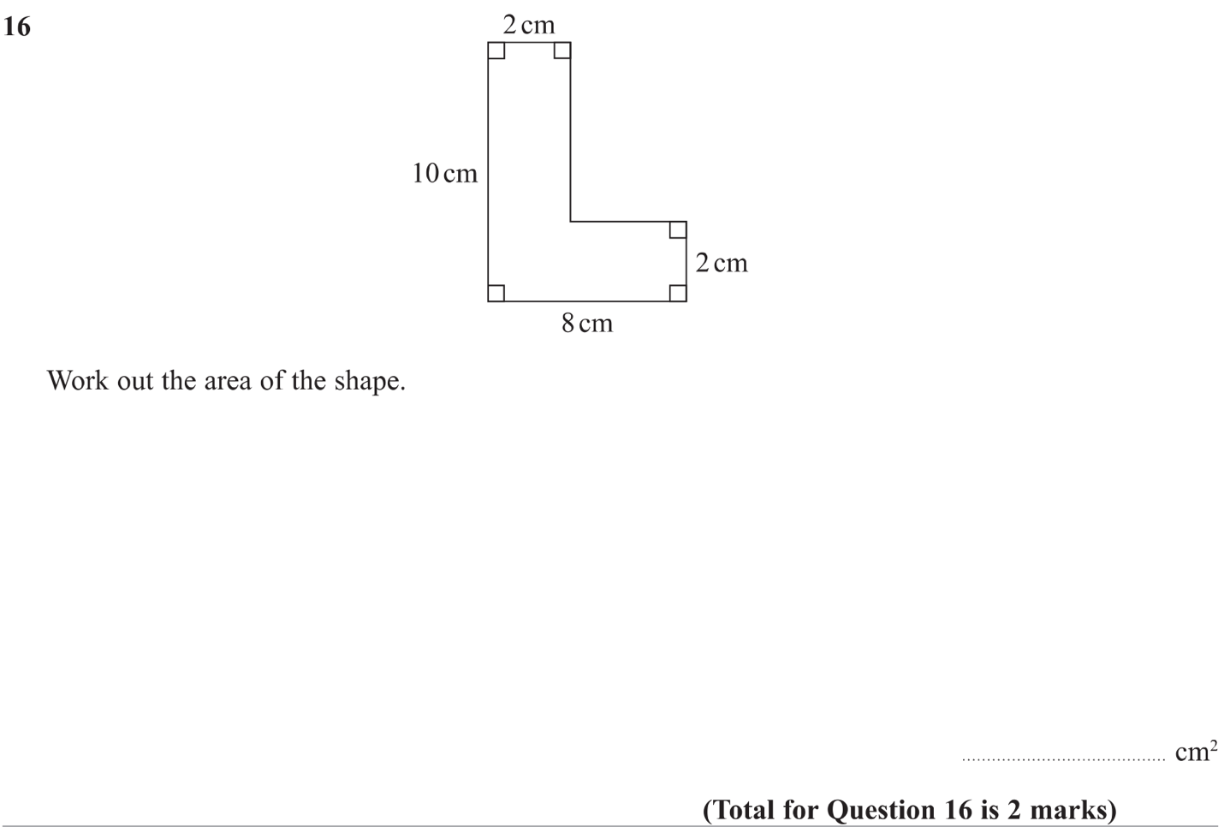

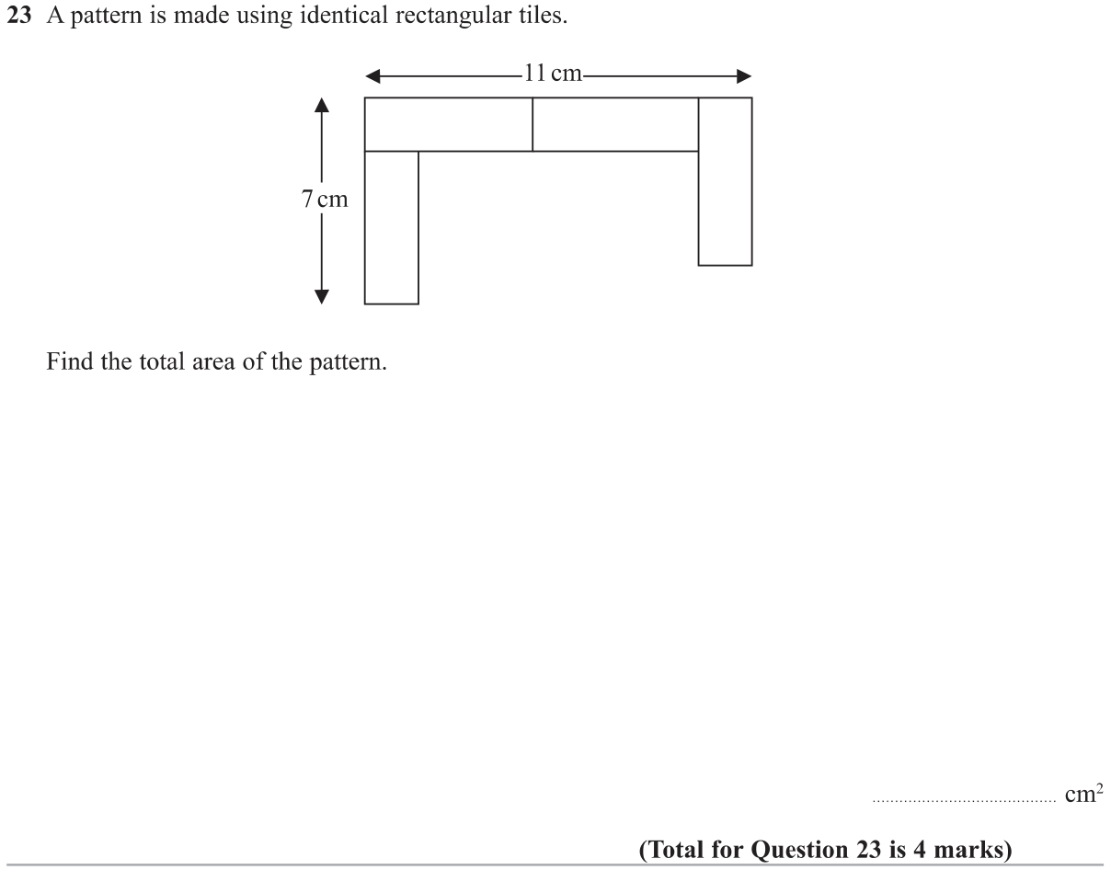

OCR – Tuesday 03 November 2020- Morning - Paper 1 (Calculator) Foundation Tier
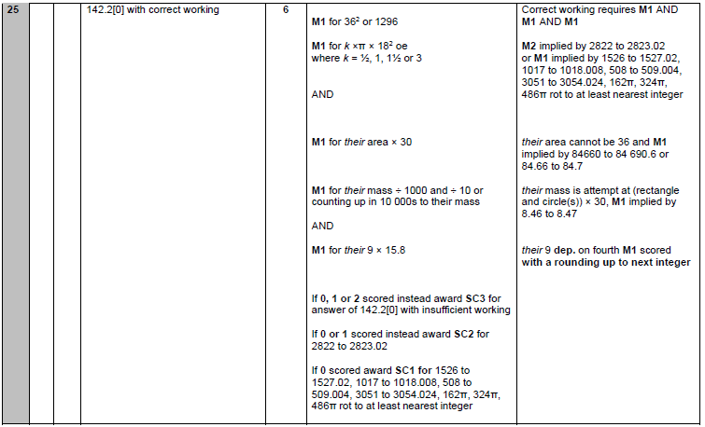

OCR Monday 6 November 2017– Morning (Calculator) Foundation Tier
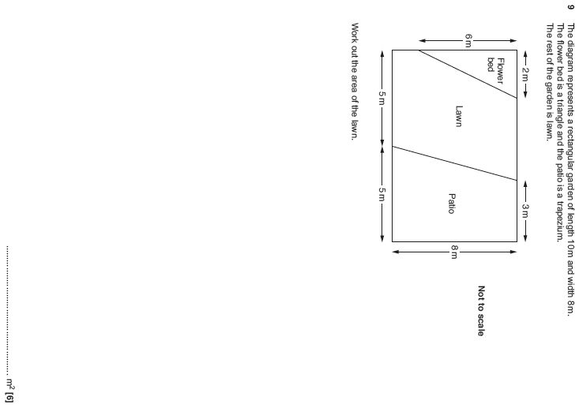

Pearson Edexcel – Sample Papers - Paper 3 (Calculator) Foundation Tier

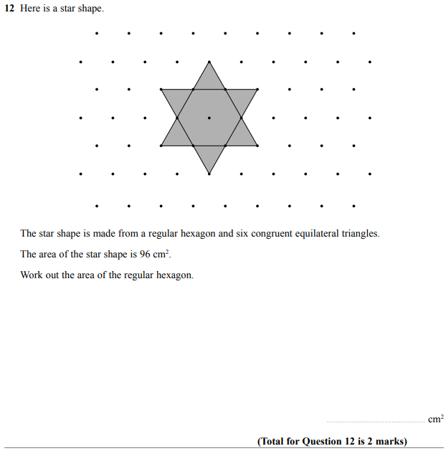

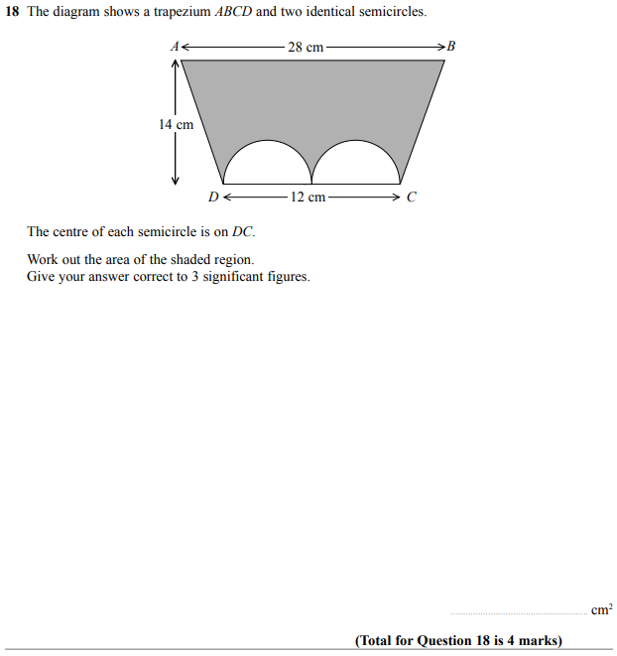

OCR Wednesday 8 November 2017– Morning (Calculator) Foundation Tier

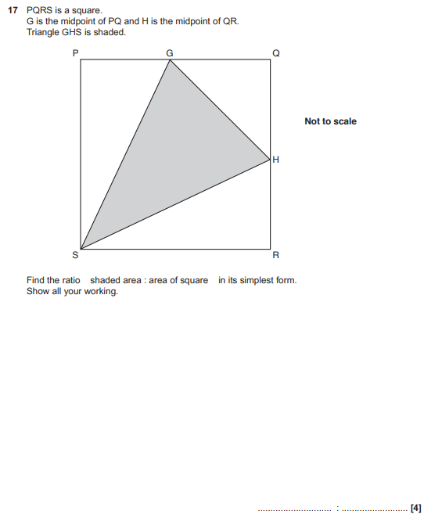

OCR Sample Question Paper 1 – Morning/Afternoon (Calculator) Foundation Tier

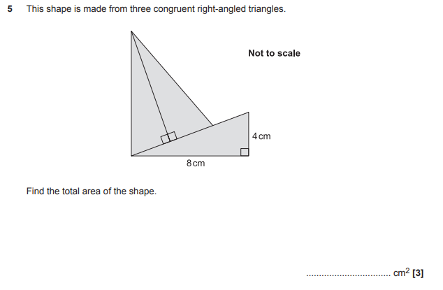

OCR Sample Question Paper 3 – Morning/Afternoon (Calculator) Foundation Tier

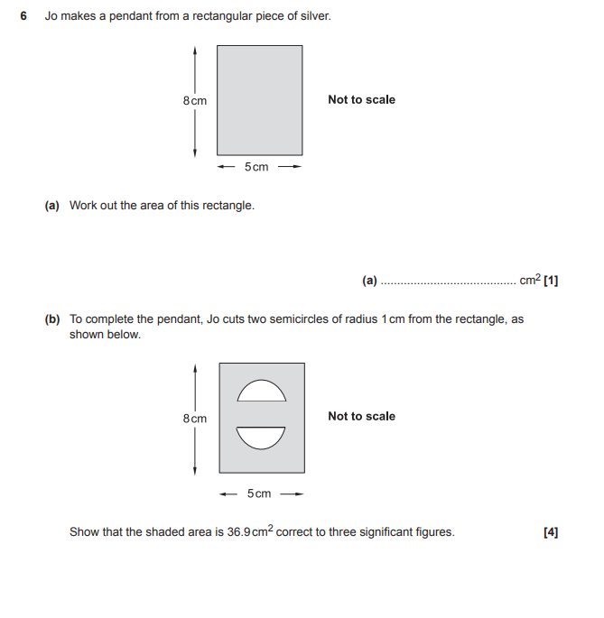

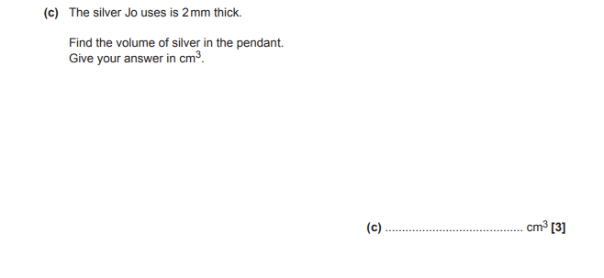

AQA Tuesday 21 May 2019 – Morning (Non-Calculator) Foundation Tier

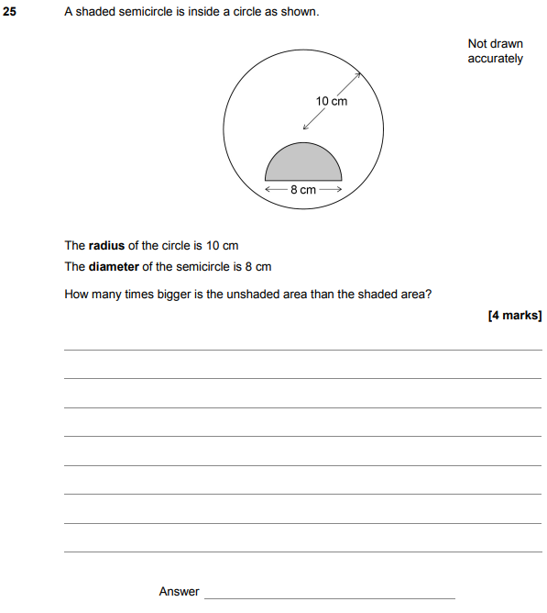

AQA Thursday 24 May 2018 – Morning (Non-Calculator) Foundation Tier

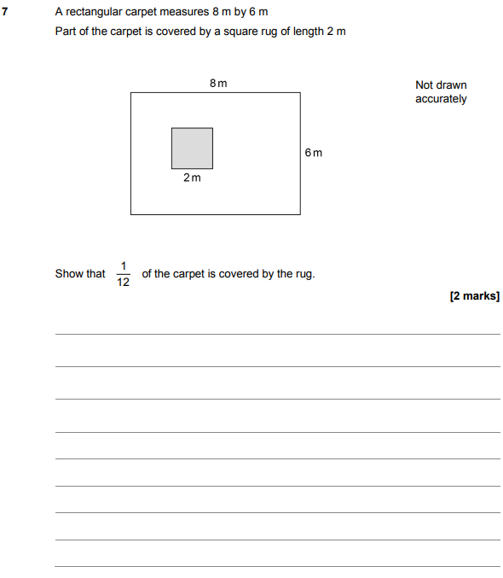

AQA Sample Paper 1– Morning (Non-Calculator) Foundation Tier

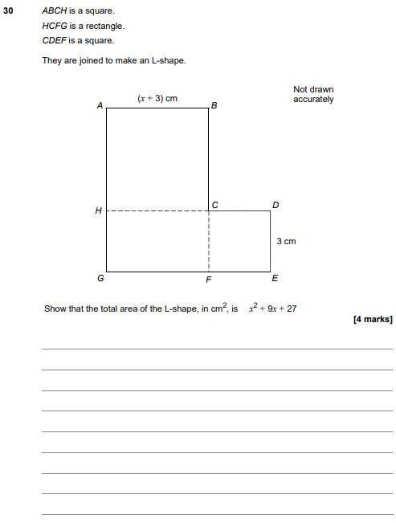

AQA Sample Paper 2– Morning (Calculator) Foundation Tier

